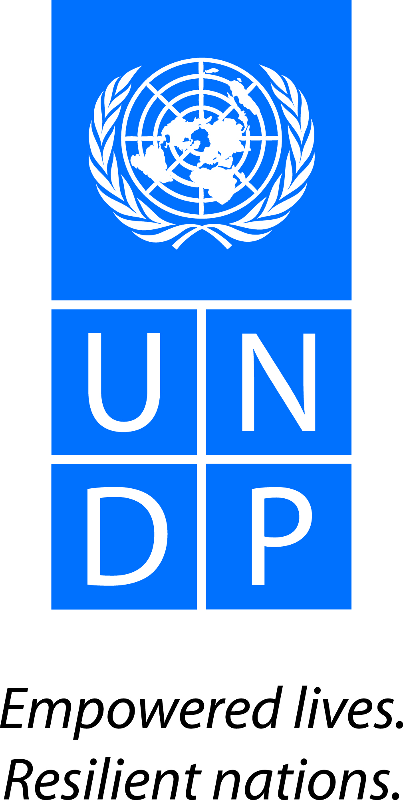
Regional Project Document

Fostering Gender Equality and Women’s Effective Participation and Contribution to Economic and Political Transformation

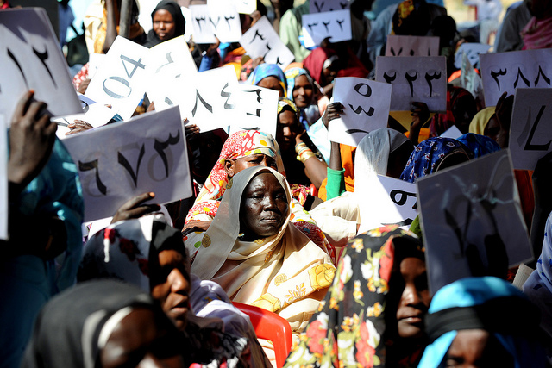

Janvier, 2015

United Nations Development Programme
Regional Service Centre for Africa
Project Document
Project Title: | Fostering Gender Equality and Women’s Effective Participation and Contribution to Economic and Political Transformation
RPD Outcome(s): |  | An integrated, prosperous and peaceful Africa, driven and managed by its own citizens and representing a dynamic force in the international arena
Expected Project Outcome(s): |  | Outcome 5: Faster progress is achieved in reducing gender inequality and promoting women’s empowerment (SP Outcome 4))
Expected Output(s): |  | Output 5.1 Regional and sub-regional legal framework and measures accelerated to advance women’s political participation and leadership  Output 5.2 Regional and sub-regional mechanisms accelerated to advance women’s economic empowerment  Output 5.3 Regional systems and regulatory frameworks in place to strengthen women’s engagement in peace and security
Executing Entity: |  | UNDP Regional Service Centre (Addis Ababa)
Implementing Agencies: |  | African Union Commission, Regional Economic Commissions (RECs), Country Offices, Civil Society Organisations, Private Sector, and UN Agencies

Brief Description
Despite the existence of well-articulated commitments, international and regional reports confirm that while some progress has been registered towards gender equality and women’s empowerment, gender based inequalities in respect to women’s participation in decision making, economic empowerment of women, violence against women still persist in Sub-Saharan Africa.This project is part of the RBA Regional Programme (2014-2017) designed to support regional integration processes to help usher in a prosperous and peaceful Africa, driven and managed by its own citizens, and representing a dynamic force in the international arena. This project has the following specific outputs that focus on strengthening women’s participation, representation and leadership, expanding economic empowerment and employment opportunities and securing women’s rights in the region: (i) Regional and sub – regional legal framework and measures accelerated to advance women’s political participation and leadership, ii) Regional and sub – regional mechanisms, measures accelerated to advance women’s economic empowerment iii) Regional systems, legal framework and measures in place to strengthen women’s engagement in peace and security. These outputs will be realized through a multi-dimensional and integrated approach of initiatives on knowledge management, capacity development, advocacy, advisory services, and strengthening alliances and coalition building between partners. The project targets a multiplicity of regional stakeholders, specifically NEPAD, African Union, RECs, selected Civil Society Organizations, Private Sector and Gender Observatories
Programme Period: 2014 - 2017
Key Result Area (Strategic Plan) SP Outcome 4
Atlas Award ID: ______________
Start date: 2015
End Date 2017
PAC Meeting Date Dec 2014
Management Arrangements DIM
Total resources required 11,000,000
Total allocated resources: 6,000,000
- Regular 6,000,000
- Other:
  - Donor _________
  - Government _________
Unfunded budget: 5,000,000
In-kind Contributions _________

Agreed by (UNDP):

situation analysis.
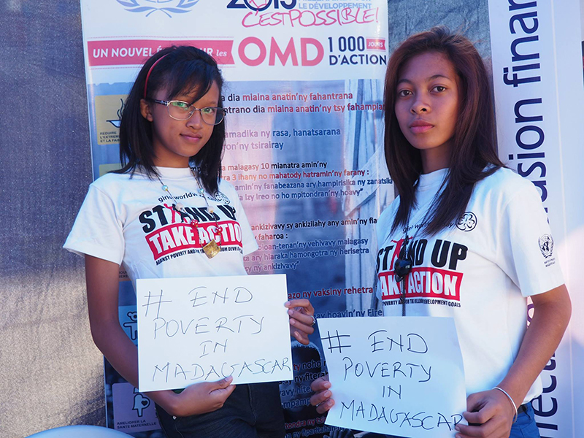
Photo: UNDP Madagascar
The United Nations Development Programme (UNDP) regional programme for Africa outlines key achievements, opportunities and challenges towards advancing sustainable human development – the process of enlarging space and inclusivity, transforming the economy to deliver for people and building a robust social contract. UNDP’s approach is underpinned by the concept of Sustainable Human Development which focuses on the process of enlarging people`s choices by expanding their capabilities and opportunities in ways that are sustainable from the economic, social and environmental standpoints, benefitting the present without compromising the future.
Africa has put its lost decades behind and made significant strides on the social, political and economic front since the turn of the century. The continent has since seen rapid democratic transitions, leading to more responsive and accountable governments. The frequency of armed conflicts is on a downward trend. Steady economic growth and macroeconomic stability have resurged. The private sector has flourished in agriculture, telecommunications, finance, retail trade, housing and construction. New technologies are spreading rapidly across the continent, especially in the areas of information and communication. Discoveries of oil, gas, and other mineral resources are creating new opportunities. Africa has been reducing extreme poverty since 1999, with expanded social policies also improving health and education services – including those targeting women and girls. Nevertheless, with all the enthusiasm there is sober recognition of unfinished challenges that are impeding the continent to reach its full potential of building “an integrated, prosperous and peaceful Africa”.
To lift the vast majority of the Africa’s citizens out of poverty and underdevelopment will need a structural economic transformation that has so far been lacking. Africa’s growth is above the global average (in 2013 Africa maintained a growth rate of 4% compared to 3% for the global economy). However the region lags behind the rest of the world in making progress towards the Millennium Development Goals (MDGs). The growth in the region is bypassing traditional employment-heavy sectors such as manufacturing, which has an important implication in poverty reduction. Africa’s growth is currently fuelled by services, agriculture, and extractive industries. The consequences of bypassing manufacturing in Africa’s growth pattern has resulted in the lack of improvement in the fundamentals of industrialisation – lower transport, cheaper and reliable power and an educated labour force that could benefit all other sectors. The result is that Africa is growing without human development. This has led to high levels of inequality and stagnant rural economies that pushes the young to seek opportunities in urban metropolises or abroad.

Countries and communities across Africa remain vulnerable to shocks, emanating from climate change, natural disasters (drought and floods mainly) and from economic, political and social instability. Conflicts, climate change and disaster risks represent interrelated challenges that are impairing the ability of Africa to advance human development and realize its structural transformation agenda. Violent conflict costs Africa around $18bn per year while Africa’s costs for adapting to climate change are increasing (USD 7-15 billion annually by 2020, up to USD 50 billion per year by 2050). Disasters contribute to between 3 and 15 per cent of annual loss of GDP in African countries. The recent Ebola outbreaks that threatened the very viability of the state in Liberia, Sierra Leone and Guinea point to extreme vulnerability to shocks that easily wash away hard-won gains. The Horn of Africa drought of 2011, the instability of the Great Lakes region, the Sahel crisis and the Ebola outbreak in Manu River Union region point to the interplay of demographic, ecological, security and political factors. These regions have faced recurrent crises that intermittently trigger temporary responses, but have not yet fully addressed the underlying drivers of instability and vulnerability, which require a more comprehensive and integrated approach towards building resilience.

With regards to Gender Equality and Women’s Empowerment, despite the progress achieved, a range of persistent challenges remains. African countries are making strides in closing gender gaps related to health and educational attainment but less so in relation to economic participation and political empowerment. Gender parity in primary schools has been achieved in 40% of African countries although completion and transition rates to secondary and tertiary institutions remains a challenge. Elected female representation in parliaments has also doubled in the last 10 years to an average of 20.9%. However, individual country performance varies and female representation in leadership positions in public and private institutions remains a challenge. Women’s economic empowerment through productive employment beyond agriculture remains low as women constitute only 39.6% of paid employment outside of the agricultural sector. The gender gap in women’s participation in the labour market translates to a reduction in economic output equivalent to an annual economic loss exceeding $60 billion for sub Saharan Africa. The challenges to be addressed in promoting gender equality and women’s empowerment in Africa include: women’s unequal access to economic resources and assets, including environmental goods and services and environmental finance, women’s unequal access to basic services, discrimination against women in the workforce, manifesting in unequal pay and vulnerable employment; unacceptably low levels of female participation in decision making; high levels of violence against women and girls, high levels of maternal mortality; and a disproportionate impact on women of the effects of climate change, including natural disasters and Ebola disease. Discrimination is often related to macro and social policies, institutions, customs and traditions that have implications for the lives of women, but also hold back progress for their families and countries as a whole.

An inclusive political process that opens space for voice and participation is fundamental in building a cohesive and vibrant society. The recent uprising in Burkina Faso, near state collapse in Mali and growth of violent extremism points to the unfinished business of deepening democratization and opening space. To ensure greater transparency and accountability in the allocation of resources, the expectations of citizens across Africa – especially youth and women – for a fuller engagement in government decisions need further progress with respect to voice and participation. Formal elections and democratic transfer of power have to translate more clearly into sustained, meaningful development outcomes, specifically through improved public service delivery and effective management of public and natural resources. Equitable access to justice and human rights can improve through advances in constitutionalism, rule of law and institutional strengthening of the judiciary and the security sector. To achieve these, it is critical to further develop human and institutional capacities with a clear role for different stakeholders, including civil society organizations, women and youth.

A robust social contract is a perquisite in establishing a mutually beneficial relationship between the governed and the governors. The social contract is also critical in underlining the relationship among citizens and the ideals of the society they wish to foster. The Ebola crises in many ways highlighted in a vivid manner the very collapse of the social contract in the minds of some citizens. Many risked catching the deadly virus rather than believe what state institutions were saying. Although progress has been made on the democratisation front with the growth of representative and inclusive governments, the continent needs second-generation governance systems that goes beyond elections and builds a social contract that outlines the mutual rights and responsibilities of citizens and what to expect from a capable state. Without a robust social contract that underpins citizenship then the relationship between people, and the people and the state will remain artificial and undermine social, political and economic growth in the continent.

Africa is undoubtedly at a strategic inflection point and in order to seize the historic momentum presented by the gains made, it must make significant changes to avoid stagnation and meet its full potential. Although the current path has led to important improvements it is not sufficient or transformational enough to respond to challenges ushered by the youth bulge, growth of urbanisation and the urgency of lifting masses out of poverty. The challenges mentioned above are further amplified by a changing demographic landscape. Africa is seeing the largest ever growth of unplanned and unmanaged urbanization, as many young people devoid of opportunity in rural areas move into cities thereby creating a swath of semi-governed, overcrowded and poorly sanitized slums. This rapid urbanization represents new frontiers in the development challenge for many African countries, particularly in how to deliver services in informal settlements, capacities for effective city planning, and insecurity especially for women. It is in these slums that Ebola was for the first time urbanized, presenting a complex challenge and overwhelming the already fragile health systems. Excessive urban concentration provides both opportunities for development take-off but also poises unique challenges that demand conceptual shifts in how jobs are created, and how services and security are provided.

The unfinished business that are impairing the ability of Africa to further advance human development and reach its full potential could be summed as: (a) lack of real economic structural transformation that lifts all of Africa’s citizens, (b) opening of space for inclusive participation, and (c) fragile social contract and low levels of resilience to economic, political, social and environmental shocks. It is in these three areas where UNDP’s five regional projects will focus its interventions. In addition to the challenges and opportunities set out above UNDP’s regional work responds to the aspirations of Africa articulated by the African Union and other regional organs. These are convergent with the vision, guiding principles and areas of work of the UNDP Strategic Plan 2014-2017, and the directions of the quadrennial comprehensive policy review. The five mutually reinforcing regional projects builds on the successes and responds to the lessons from past cooperation, and is aligned to the UNDP Strategic Plan at the thematic, design and operational level.

The proposed specific project will focus on supporting regional bodies to put in place an enabling environment for women and men to effectively contribute to the economic structural transformation process, to participate and be represented in the leadership positions at all levels, and strengthen their contribute to the social cohesion programmes. The project will support regional and sub-regional institutions to adopt inclusive, appropriate and equitable legal frameworks, policies and measures to accelerate the advancement of women’s rights. The project will also support the development of a strong component of research and analysis to identify gaps and best practices to inform its advocacy and policy work. A particular focus will be put to women in conflict and post conflict settings.

Strategy
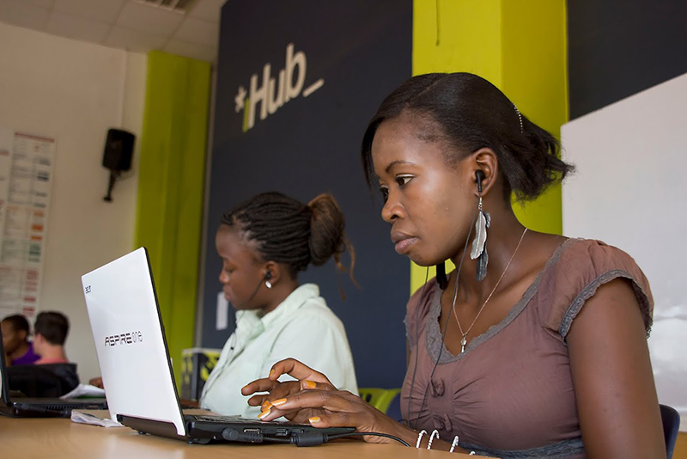
Photo: iHub, Kenya

This project will focus on UNDP’s specific contributions towards gender equality and the empowerment of women as articulated in the UNDP Strategic Plan, the Gender Equality Strategy and several regional frameworks such as the AU’s Agenda 2063, the AU Africa Women’s Decade and Protocol to the African Charter on Human and Peoples' Rights on the Rights of Women in Africa, the AU Gender, Peace and Security Programme, Regional Peace Plans for IGAD, ECOWAS, ECA, SADC and COMESA, and the SADC Gender and Development Protocol. The project interventions will be at the regional level with linkages at the sub-regional level as well as national level in identified countries.

This project is in line with UNDP's regionality principles and leverages UNDP's interventions and strategic presence at the country level. The project is designed to respond to regional challenges that cannot be undertaken at a national level such as cross-border issues, support to regional entities such as the African Union and Regional Economic Commissions and increased national uptake of regional instruments. The project aims to support domestication of key regional frameworks, experiences and international best practice through national development plans and strategies. The design of the project was undertaken in consultation with Resident Coordinators who helped identify key regional challenges that are inhibiting national development. The project also received significant inputs from UNDP's global programme managers, the Executive Office of the Administrator, the Development Impact Group of BPPS and representatives of partner institutions and civil society. The project will be implemented within the framework of the regional programme.

Theory of Change
In line with the ambitious post 2015 agenda, a transformational approach is required to address the underlying structures of power that exists across all societies that promote gender inequality. Change needs to be affected at the level of an individual, as well as through systemic structural changes to contribute to the elimination of discriminatory laws and practices such as the norms and culturally discriminatory practices that maintain inequality and exclusion and ensure socio economic and political empowerment of women. The theory of change is based on the understanding that sustainable human development will not be fully achieved unless women and girls are able to expand their political space and effectively participate and influence the decision making processes at all levels, contribute to economic structural transformation on an equal basis with men and boys and be capacitated to play a key role in the social cohesion and peace processes. Gender equality, in addition to being a human right, has been shown to have significant multiplier benefits for women, their families and communities.

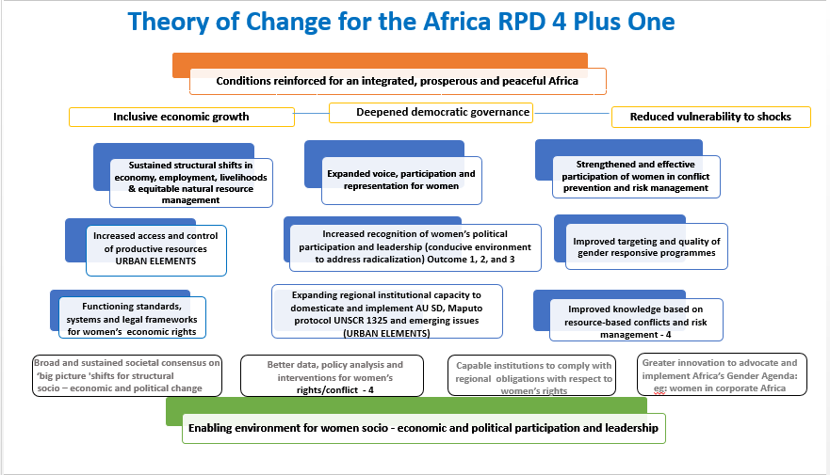

Project Approach
The regional project on gender will contribute to enhancing institutional capacity for promoting gender equality and women’s effective participation, leadership and contribution to economic and political transformation and peace and security in Africa. The project approach will specifically build on UNDP’s strengths and lessons learned from the previous regional project (2008-2013) and the ongoing UNDP/AU Gender project (2013 – 2016) aimed at promoting an enabling environment for women’s economic empowerment & political participation in Africa creating complementarity in implementation. Internal synergies will be forged with all the four regional projects being implemented through RBA Regional Programme to ensure that gender is mainstreamed in all the projects and to tap into the financial and human resources.

Realizing that gender inequality is indivisible, the project will contribute to effective knowledge management and dissemination of best practice and lessons learned and promote evidence based and inclusive advocacy and policy dialogue in support of women’s economic rights and increased access to and control over productive resources. The project will also contribute to institutional capacity development including peer to peer learning between African countries and south-south cooperation to expand women’s voice and participation in leadership. The project will include a strong component of evidence based research and learning in order to inform policy/advocacy work. Based on improved knowledge/evidence made available, the project will focus its advocacy and technical advisory work on the regional institutions/bodies to support the review and adoption of gender responsive policies, legal reforms, measures, systems and standards that accelerate the advancement of women’s socio-economic and political rights and strengthen the capacity of the key regional institutions partners for their ownership. The project will also focus on strengthening institutional capacity for accelerated implementation and monitoring of commitments and programs to promote gender equality and women’s empowerment.

In particular, acknowledging the particular vulnerability of women in crisis and post-conflict recovery settings, the project will enhance the understanding of the underlying causes, impacts and response to resources based conflicts (land, extractives, climate change) from a gender perspective. Special attention will be paid to the issues underlying women’s labour force participation, representation in leadership public/ regional institutions and contribution in peace building, and conflict mitigation processes. The implementation of the regional project will benefit from the close partnership with UN Women, UNFPA and other relevant stakeholders. The project will therefore contribute to increase women control over productive and natural resources and employment opportunities, expand their voice, effective participation and representation in decision making and peace processes positions which will allow them to contribute to the much needed economic structural transformation and social cohesion.

The project’s knowledge management and communication strategy will ensure constant engagement with project stakeholders and steady flow of information that highlights challenges, success stories and real life experiences from women in different spheres of public life including their role in peace building and mediation efforts. The studies and knowledge products generated by the project will be used to help foster interaction between the different stakeholders using web based sharing platforms. All knowledge products will be developed in both English and French, so that they are accessible to a wide range of stakeholders.

Sustainability of support

Capacity development is a long-term process that will not fully be achieved within this project cycle. However, this project's approach is to ensure sustainability of support as a key consideration in choices made and the parameters of the project design, hence our contribution to an integrated, prosperous and peaceful Africa as outlined in Vision 2063. The capacity development initiatives identified in this project are to enhance the core functions of regional bodies and support implementation of their strategic plans. UNDP will support these bodies ability to secure more internal resources to realise their core functions and plans. As part of the sustainability plan, UNDP will jointly implement activities with key UN partners and other multilateral organizations to better coordinate and ensure sustainability for results. Furthermore the Monitoring and Evaluation plan of this project will continuously monitor and assess UNDP’s support and key milestones over the project period, and recommend corrective approaches to ensure sustainability of interventions.

Project Synergies:

This project is implemented in the framework of the Regional Programme and is therefore complementing the four other projects developed to support the implementation of the Regional Programme Document 2014-2017. The project complements the Outcome 1, as they will both promote economic growth strategies and policies that are inclusive and distributive and empower women through tackling regulatory obstacles that restrict their access to and control over economic opportunities. Both projects will contribute to enhancing men and women’s productive capacities and regional policy frameworks that create employment opportunities and also access to decent jobs and labour market. In the same vein, an explicit support to link women’s economic empowerment to investments in emerging markets and opportunities such as climate change, value-chains, natural resources and extractive industry will be provided.
The project complements also the Transforming Governance in Africa Outcome 2 project through supporting several initiatives under this outcomes including enhancing political participation of women with particular focus on reducing gaps between countries in terms of women’s access to elected offices, but also on achieving gender parity in regional structures. The concept of women’s participation will be analysed beyond Parliament and National Governments seats, to reflect the extent to which gender dynamics are transformed in local governance structures, in private sector and in civil society organizations. Both project will also collaborate to address the social and economic challenges posed by natural resource governance on men and women and how effective and inclusive management of these resources could be a major accelerator towards inclusive economic transformation.
This Outcome 3 project Fostering Resilience to Shocks and Threats in Africa focuses on resilience. Both outcomes 4 + 1 and 3 will collaborate to support the peace consolidation and social cohesion initiatives in the Sahel, Great Lakes initiatives and Horn of Africa strategies and projects. Together with the African Union and the AU special envoy on Peace and Security, both projects will ensure that gender issues are appropriately addressed in conflict prevention and peace building initiatives. They will also collaborate with the African Union Commission to embed gender principles in the implementation of the UA’s infrastructures for peace, including the Pan-African Network of the Wise, a key institution of the African Peace and Security architecture, and its linkage with the African Insider Mediators Platform. They will finally ensure that the interests of both men and women are taken into account in developing resilience strategies associated to natural disasters including climate change.
The project also complements the Strengthening African Engagement in Global Development Debates Outcome 4 as they will both contribute to regional and sub-regional dialogues and platforms that provide innovative solutions for development that is gender compliant and takes into account the interests of both men and women. Specifically, they will collaborate to generate evidence on how to leverage African economic growth by boosting gender equality and women’s empowerment, including women’s access to better jobs, to economic opportunities particularly access to national and regional and international markets, as well as ownership and property rights, their access to technologies that mitigate the impact of climate. Finally, they will support analysis that bring evidence on the correlation between women’s leadership and political participation and the power to transform politics, rule of law and democratic governance structures to make them gender responsive and drivers of social justice, gender equality and women’s empowerment.
In addition to the above four regional projects, the outcome plus one project will complement the ongoing UNDP/AU Gender project (2013 – 2016) aimed at promoting an enabling environment for women’s economic empowerment & political participation, creating complementarity in implementation. While the UNDP – AU focuses its support to African Union Departments to ensure policies, strategies and programmes are gender responsive, the outcome plus one project will emphasize on gender, peace and security and capacity development for gender responsive planning and budgeting in UNDP programmes. It will also support other partners such other regional institutions and Civil Society Organisations to promote women’s effective participation in economic growth and decision making positions at all levels.
Project Outputs
Three interrelated project outputs will be implemented to contribute to the achievement of the project outcome “fostering the inclusive participation and effective contribution of women in the process of economic and political empowerment”: These include:

- Regional and sub-regional legal frameworks and measures in place accelerated to advance women’s participation and leadership
- Regional and sub-regional policies mechanism accelerated to advance women’s economic empowerment
- Regional systems and frameworks in place to strengthen women’s engagement in peace and security

Output 1: Regional and sub – regional legal frameworks and measures accelerated to advance women’s political participation and leadership;
This component aims to contribute to a shared understanding of underlying factors that undermine the participation of women in leadership in the public domain, and to identify the priorities and action points to promote their participation accordingly. Building on UNDP assessments such as Gender Equality in Public Administration (GEPA), the State of Public Service in Africa (SOPSA) and the African Human Development Report on Gender Equality and Women’s Empowerment as well as interactive dialogue with a broad range of stakeholders an action agenda will be developed to address gaps related to existing legal frameworks and accelerate their implementation at regional and sub-regional levels. The agenda for action will address the laws, policies and the realization of women’s rights related to political participation, constraints that restrict women’s participation in public life, and women’s participation and representation in decision-making spaces and in leadership. The regional agenda for action will be informed by sub-regional assessments and selected national case studies. This agenda for action will inform UNDP’s institutional support for regional, sub - regional institutions and partners. This activity will be undertaken in close collaboration with UN Women, FEMNET and regional Gender Observatories. This component will also support the development of a toolkit for mainstreaming gender perspectives in constitutional and electoral reforms. These outputs will expand women’s voice, their effective participation, representation and leadership at all levels.
Activity Result 1.1.1: Conducive environment in place at regional and sub-regional levels for women political participation, representation and leadership acceleration.

Indicative activities:
- Interactive regional assessment on legal and institutional barriers to women’s political participation, appropriate strategies/best practices and a roadmap of priority policy actions. The assessments will evaluate the following and identify action points accordingly: Constitutions/legislations, national policies, and women’s rights charters/ acts/ bills Women’s rights observatories and parliamentary at regional and sub – regional levels;
- Review existing training, mentoring and advocacy programmes on women’s preparedness for effective political leadership, identify gaps and promote upscaling at regional and sub-regional levels;
- Develop toolkit for assessing capacity for mainstreaming gender in constitutional and electoral reforms and designing appropriate institutional capacity development strategies;
- Provide advisory support to advocacy for domestication of some existing global, regional and sub-regional instruments (Maputo Protocol, AU Solemn Declaration) and strengthen monitoring, reporting, and accountability at all levels;
Activity Result 1.1.2: Gender responsive regional Institutional effectiveness and accountability.

Indicative activities:
  - Promote multi-stakeholder dialogue platforms – linked to planned regional events - for inclusive debate by public, private and civil society organisations on gender responsive public and private institutions with effective participation from regional civil society organisations
  - Provide technical advisory services for the development and implementation of capacity development frameworks for gender responsive planning, resource allocation, monitoring and implementation in UNDP strategic priority areas at all levels (Gender SEAL, national and regional level actions);
  - Develop capacity in regional gender observatories for monitoring progress in regional institutional effectiveness, development and adaptation of training material, and use of online tools for documenting best practices in enhancing regional institutional effectiveness

Output 2: Regional and sub – regional mechanisms accelerated to advance women’s economic empowerment:
In respect to women’s economic empowerment, the project will be implemented through partnerships with NEPAD, the AU, identified RECs, the AU/UNDP Regional Gender Project, Ministries of Finance and Trade, and Parliaments, and also build on the Africa Facility for Inclusive Markets (AFIM) project. Project activities are aimed at supporting the implementation of regional/sub-regional policies, laws, programmes that reduce and eliminate barriers to women’s economic empowerment through regional policy and legislative reforms to ensure women’s equal access to and control over productive assets. Activities will contribute to enhancing collaboration between public and private institutions and incorporating gender perspectives into macro-economic frameworks and strategies for promoting agricultural transformation and structural change. Support will be provided for RECs as they engage national governments in policy dialogues for the domestication of regional and international instruments that advocate for women’s economic and social empowerment. The emphasis of this project is to enhance knowledge and information sharing on opportunities to enhance women’s contribution and benefit from extractive industries, agro-based value addition, mining beneficiation, climate change financing and to reflect a paradigm shift in which women are innovative, proactive, risk taking and are change agents.

Activity Result 2.1.1: Regional agricultural and economic transformation strategy implementation increasingly integrates gender perspectives and contributes to women’s economic empowerment
  - Support the integration of gender perspectives in the implementation of key regional and sub-regional initiatives including NEPAD/CAADP work plans and budgets;
  - Promote the integration of gender responsive strategies for structural transformation in regional dialogue with member states on trade including the development of policy briefs and support to effective engagement of women’s organisations in discussion on the trans-continental free trade areas.
  - Promote advocacy and policy dialogue between RECs and private sector for enhanced opportunities for women’s entrepreneurs including business incubators based on assessments and policy briefs on women’s participation and contribution in the corporate sector (trade, finance, extractives, mining, agribusiness, climate change);

Output 3: Regional systems and legal framework in place to strengthen and capacitate women’s engagement in peace and security:
Resolutions on Women Peace and Security 1325, 1820, 1888, 1960, 2106, and 2122 recognize the disproportionate impact of armed conflict on women, and stress the importance of women’s leadership, influence, and political participation and representation in conflict, post conflict and political transitions. As a number of Sub Saharan countries, such as Central Africa Republic and South Sudan remain in conflict, the security of women in those countries, as well as those who have been displaced and live in refugee communities in neighbouring countries requires special attention. The AU Special Envoy on Women, Peace and Security was appointed and a regional programme on Gender Peace and Security 2014 – 2018 was launched by the AUC Peace and Security Directorate.

This project will provide advisory services to the domestication of UNSCR 1325, development and implementation of sub-regional and national action plans to increase women’s participation and representation in peace processes and prevent and protect women and girls from SGBV. The project will strengthen the capacity of women’s networks to voice their concerns against SGBV, including identified male networks to assist in campaigning against violence against women. Additionally the project will provide advisory services to regional and national actors to ensure justice and security systems protect women against SGBV through enabling laws, increased justice for the survivors, gender sensitive law enforcement agents and the advocacy for legal aid. The project will commission evidence based research on the increasing regional challenges associated with SGBV related resource conflicts. In addition the focus on engaging men and including them in training and campaigns against SGBV brings a new approach of using men to engage other men and speak out against SGBV as agents of change. This proposed set of activities will be undertake in close collaboration with UN Women and other stakeholders and build on ongoing work undertaken by partners.

Activity Result: 3.1.1: Strengthened measures for women’s engagement in peace and security
  - Set up and train a regional roster of women mediators for peace and security;
  - Identify regional champions and organize regional advocacy events for women’s peace and security and prevention of SGBV;
  - Advisory support to the implementation of the AUC Peace and Security programme on GPS specifically with special focus on the SGBV prevention dimension (measures, systems and capacity of appropriate regional institutions):
  - Commission regional research on resources based conflicts and the impact on women and the socio cohesion (land, extractives, and climate change) and develop regional follow-up action plans to implement the research findings;
  - Comparative study on role of women in fragile/post conflict (CAR, South Sudan, Mali and DRC) with recommendations on programming;

Results and Resources Framework
Intended Outcome as stated in the Regional Programme Results and Resource Framework:
Gender equality and empowerment of women (including their participation in peace negotiations and post crisis construction ) and implementation of the Gender Action Plan
Outcome indicators as stated in the Regional Programme Results and Resources Framework, including baseline and targets:
Indicators
- Women’s access to credit ( commercial and micro-credit) (SP 4)
- Proportion of women to men in Parliament (SP 2).
- Proportion of women subjected to physical or sexual abuse in the last 12 months (SP4).
- Proportion of decision making positions in peace building processes which are occupied by women (SP4)

Baselines
- Four countries – Kenya, Ethiopia, Uganda, Ghana
- 80% of countries in Sub Saharan Africa yet to reach 30 %
- No harmonized data collection system exists
- Women participated in 6 peace processes out of 15 (40%)

Targets 2017
- Fifteen countries
- 40% of countries to reach 30%
- 1 sub – regional harmonized data collection system adopted
- 70% of peace processes include women

Applicable Key Result Area (from 2014-2017 Strategic Plan): Outcome 4 Faster progress is achieved in reducing gender inequality and promoting women’s empowerment
Partnership Strategy
This regional gender project builds on past and on-going gender equality and women empowerment interventions within the RBA and those supported by other UN agencies in particular UNWOMEN IFIs, and other development partners. The project will be closely implemented in collaboration with the AU/UNDP project Enabling Environment for Women’s Political and Economic Empowerment in Africa which supports the AUC Commission. Recognizing that some of the outputs of this project overlap with other outcomes and outputs under the RPD, there will be internal partnerships and synergies to ensure joint implementation for the related activities. Furthermore, the project will collaborate with RECs, regional and sub-regional civil society organizations, political parties and national, sub-regional and regional parliaments, local government, gender machineries, governments, think tanks, business and professional associations.
Project title and ID (ATLAS Award ID): Fostering the Inclusive Participation and Effective Contribution of Women in Process of Economic and Political Empowerment
INTENDED OUTPUTS | OUTPUT INDICATORS | INDICATIVE ACTIVITIES | RESPONSIBLE PARTIES | INPUTS
Output 1  Regional measures accelerated to advance women’s political participation and leadership; | 1.1 Number of RECs that adopt roadmap to increase the number of women in decision making positions based on dialogue/advocacy/awareness meetings;  Baseline 2014- 0  Milestone 2015 – 1  Milestone 2016 - 2  Target 2017 - 3  1.2 Number of Regional and Sub regional institutions enabled that support the gender mainstreaming in constitutional and electoral review reforms in their Member States;  Baseline 2014- 1 (SADC)  Milestone 2015 – 1 (SADC)  Milestone 2016 - 2  Target 2017 - 3  1.3 Number of regional observatories with women’s rights tracking standards adopted.  Baseline 2014- 0  Milestone 2015 – 0  Milestone 2016 - 1  Target 2017 - 2 | Activity Result 1.1.1 Conducive environment in place for WPP acceleration.  - Interactive assessment of legal and institutional barriers to women’s political participation, appropriate strategies/best practices and priority policy roadmap;  - Gap assessment of existing training, and advocacy programmes for women’s effective political participation and transformational leadership;  - Develop toolkit for institutional capacity development for mainstreaming gender in constitutional and electoral reforms.  - Advisory support to advocacy for domestication, monitoring, reporting and accountability for regional and sub-regional instruments (Maputo Protocol, AU Solemn Declaration);  Activity Result: 1.1.2 Gender responsive Regional Institutional effectiveness and accountability  - Promote multi-stakeholder dialogue platforms for inclusive debate on gender responsive public and private institutions  - Technical advisory services for capacity development in respect of gender responsive planning, budgeting and implementation in UNDP programmes (GES) and documentation of best practices.  - Support capacity development of regional gender observatories for gender responsive regional institutional effectiveness monitoring and reporting. | EAC, ECCAS, SADC, ECOWAS and AUC  FEMNET  UN Women  Political Parties  AUC – Gender Directorate  PA  RECs,  AUC, NEPAD, CSO’s  Gender Team, COs, RBA, | International and national consultant(s), capacity and technical support:  Travel/DSA: 1,800,000  Translation and printing:  Workshops Venue, equipment, conference services, translation: 400,000  Communication, IT, advocacy, and dissemination: 200,000  US $ 2,400,000  Regional consultant(s);  Travel/DSA  Workshops Venue, Equipment  US $ 1,000,000
Output 2  Regional measures accelerated to advance women’s economic empowerment; | 2.1 Number of RECs that integrate a gender perspective in the implementation of flagship strategies and programs (e.g. CAADP, Trans Continental Free Trade Areas, PIDA, Innovation/Technology etc. etc);  Baseline 2014- 0  Milestone 2015 – 0  Milestone 2016 - 1  Target 2017 - 2  2.2 Number of regional assessments and policy briefs on women’s participation and contribution in corporate sector (trade, finance, extractives, mining, agribusiness, climate change) used to advocacy and dialogue between RECs and private sector .  Baseline 2014- 0  Milestone 2015 – 0  Milestone 2016 - 1  Target 2017 - 3 | Activity Result 2.1.1: Regional agricultural and economic transformation strategies and programs integrate gender perspectives  - Technical advisory services for integration of gender perspectives in implementation of flagship regional initiatives including NEPAD/CAADP work plans and budgets;  - Support women’s organisation effective participation in discussion on trans-continental free trade areas including targeted policy briefs on women in regional trade.  - Assessments and policy briefs on women’s participation and contribution in the corporate sector (trade, finance, extractives, mining, agribusiness, climate change) to inform advocacy and dialogue between RECs and private sector for enhanced opportunities for women entrepreneurs (including business incubator services) | UN Women  NEPAD  ECCAS, EAC, SADC, COMESA,  AFARD  UNIDEP  UNECA  AUC | International and national consultant(s), capacity and technical support:  Travel/DSA: 1,600,00  Translation and printing: 200,000  Workshops Venue, equipment, conference services, translation: 400,000  Communication, IT, advocacy, and dissemination: 200,000  US $ 2,400,000
Output 3  Regional systems and measures in place to strengthen women’s engagement in peace and security; | 3.1 Number of RECs and other regional organizations with SGBV data collection system harmonized;  Baseline 2014- 0  Milestone 2015 – 0  Milestone 2016 - 1  Target 2017 - 1  3.2 Number of RECs with regional action plans on 1325 implementation  Baseline 2014- 2  Milestone 2015 – 3  Milestone 2016 - 4  Target 2017 - 5  3.3 Number of RECs and other regional Institutions with adopted roadmaps to support MS to put in place SGBV preventive measures;  Baseline 2014- 0  Milestone 2015 – 1  Milestone 2016 - 2  Target 2017 - 3 | Activity Result 3.1.1 Strengthened measures for women’s engagement  - Set up and train a regional roster of women mediators for peace and security  - Identify regional champions and organise regional advocacy events for women security and prevention of SGBV  - Advisory support to the AUC Peace and Security Programme on GPS – special focus on SGBV prevention dimensions  - Commission regional research on resources based conflicts and impact on women and the socio cohesion (land, extractives, and CC) and develop regional follow-up action plans to implement the research findings;  - Comparative study on role of women in fragile/post conflict (CAR, South Sudan, Mali and DRC) with recommendations on programming; | AUC,  RECs  CSOs  Women’s platforms for peace and security  UN Women | International and national consultant(s), capacity and technical support:  Travel/DSA:: 2,800,000  Translation and printing: 400,000  Workshops Venue, equipment, conference services, translation: 1,200,000  Communication, IT advocacy, and  Dissemination; 800,000  US $ 5,200,000

Annual Work Plan (will be developed by January/2015)
Year: 2015

EXPECTED OUTPUTS  And baseline, indicators including annual targets | PLANNED ACTIVITIES  List activity results and associated actions | TIMEFRAME |  |  |  | RESPONSIBLE PARTY | PLANNED BUDGET
 |  | Q1 | Q2 | Q3 | Q4 | RESPONSIBLE PARTY | Funding Source | Budget Description | Amount
Output 1  Baseline:  Indicators:  Targets:  Related CP outcome: | 1. Activity Result  -Activity action  -Activity action
2. Activity Result
-Activity action
-Activity action
3. Activity Result
- Activity action
- Activity action
4. Activity Result
-Activity action
-Activity action
Output 2  Baseline:  Indicators:  Targets:  Related CP outcome: | 1. Activity Result  -Activity action  -Activity action
2. Activity Result
-Activity action
-Activity action
Output 3
Baseline:
Indicators:
Targets:
Related CP outcome:
TOTAL

Management Arrangements
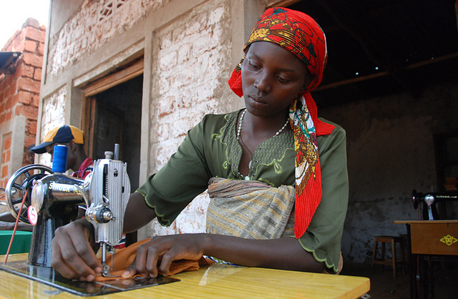
Photo: UNDP Burundi/Aude Rossignol

The regional project documents are derived from the Regional Programme Document (RPD) for Africa 2014-2017. The RPD was prepared under the leadership of the Regional Bureau for Africa (RBA) through a consultative process involving the African Union Commission, Regional Economic Communities, Civil Society Organizations, the Regional Service Centre for Africa and Country Offices.

The RBA Director provides overall strategic direction of the regional programme and the five project documents to support its implementation. He is supported in this role by the Deputy Regional Director and assisted by his Special Advisor. The Director of the Regional Service Centre has overall management of the regional programme. The Regional Programme Coordinator is responsible for the day-to-day management of the regional programme and its projects, ensuring clear alignment with the regional and corporate strategy and priorities.

In line with the oversight and accountability frameworks established by UNDP’s Executive Board, strategic direction and guidance for the efficient and effective implementation of the RPD 2014 – 2017 has been assigned to the Regional Programme Advisory Board. As recommended by the Quadrennial Comprehensive Policy Review (QCPR), the Advisory Board serves as a vital element of the regional programme’s strategic advisory mechanism to deliver on institutional effectiveness, especially the transparency and accountability underpinned by results-based management (RBM) and timely reporting to the relevant UNDP corporate oversight bodies on development results. Consistent with this, while also learning lessons from the last two Regional Programme cycles, the Board is broad-based, drawing from the full range of regional programme stakeholders, among them: the prime inter-governmental regional bodies, the private sector, civil society organizations (CSOs), Donors, UN Agencies and UNDP (Corporate, Regional Service Centre and Country Offices). This participatory approach builds on the consultative process employed during the formulation of RPD 2014-2017.

In ensuring that the development results of the Strategic Plan 2014-2017 are being attained, the overarching responsibility of the Regional Programme Advisory Board is to assist the RBA Regional Director to carry-out his broad oversight responsibilities, especially with regard to the accountability, monitoring and evaluation, strategic forward planning, overall results based management, quality assurance and risk management requirements of the RPD as a whole. The Board will have the following key functions:

  - Provide strategic advice on current and emerging development issues (economic, political, social) which could be addressed by the Regional Programme to ensure that: (i) policy, programmme advisory and capacity development support is responsive to Africa’s development aspirations, priorities and emerging challenges, and (ii) the initiatives of the Regional Programme are linked to and draw on those from the Global and Country Programmes, whenever appropriate;
  - Review past year’s annual reports on achievements and challenges and lessons learned and innovations from mid-term reviews/evaluations, and provide strategic advice on corrective actions, future direction, substantive scope and focus of the Regional Programme.

The project management will be led by the RSC Gender Cluster Leader. She will be responsible to achieving the respective project outputs and collectively contribute towards the RPD Outcomes. The Regional Programme accountability framework and business processes that will guide the management of this project envisions a crucial role for RSC support teams in promoting inclusion of all relevant stakeholders from across RSC Units, as well as the rest of RBA in the HQ. The effectiveness of these teams depends on an inclusive approach, based on collegiality, openness, and to encourage decision- making by consensus.
Gender Cluster Team Leader
Regional Programme Advisory Board
African Union Commission, RECs, ECOWAS and ECCAS

RBA Director
Central Bureau and RC/RR

Centre for Citizen Participation; Alliance for Commodity Trade, Africa Civil Society Platform on Principled Partnership

Regional Programme Coordinator

Project Support
Programme Organisation Structure
Output 1:
Regional measures accelerated to advance women’s political participation and leadership
Output 3:
Regional systems and measures in place to strengthen women’s engagement in peace and security;

Output 2 :
Regional measures accelerated to advance women’s economic empowerment;

Director - RCSA

Monitoring Framework And Evaluation
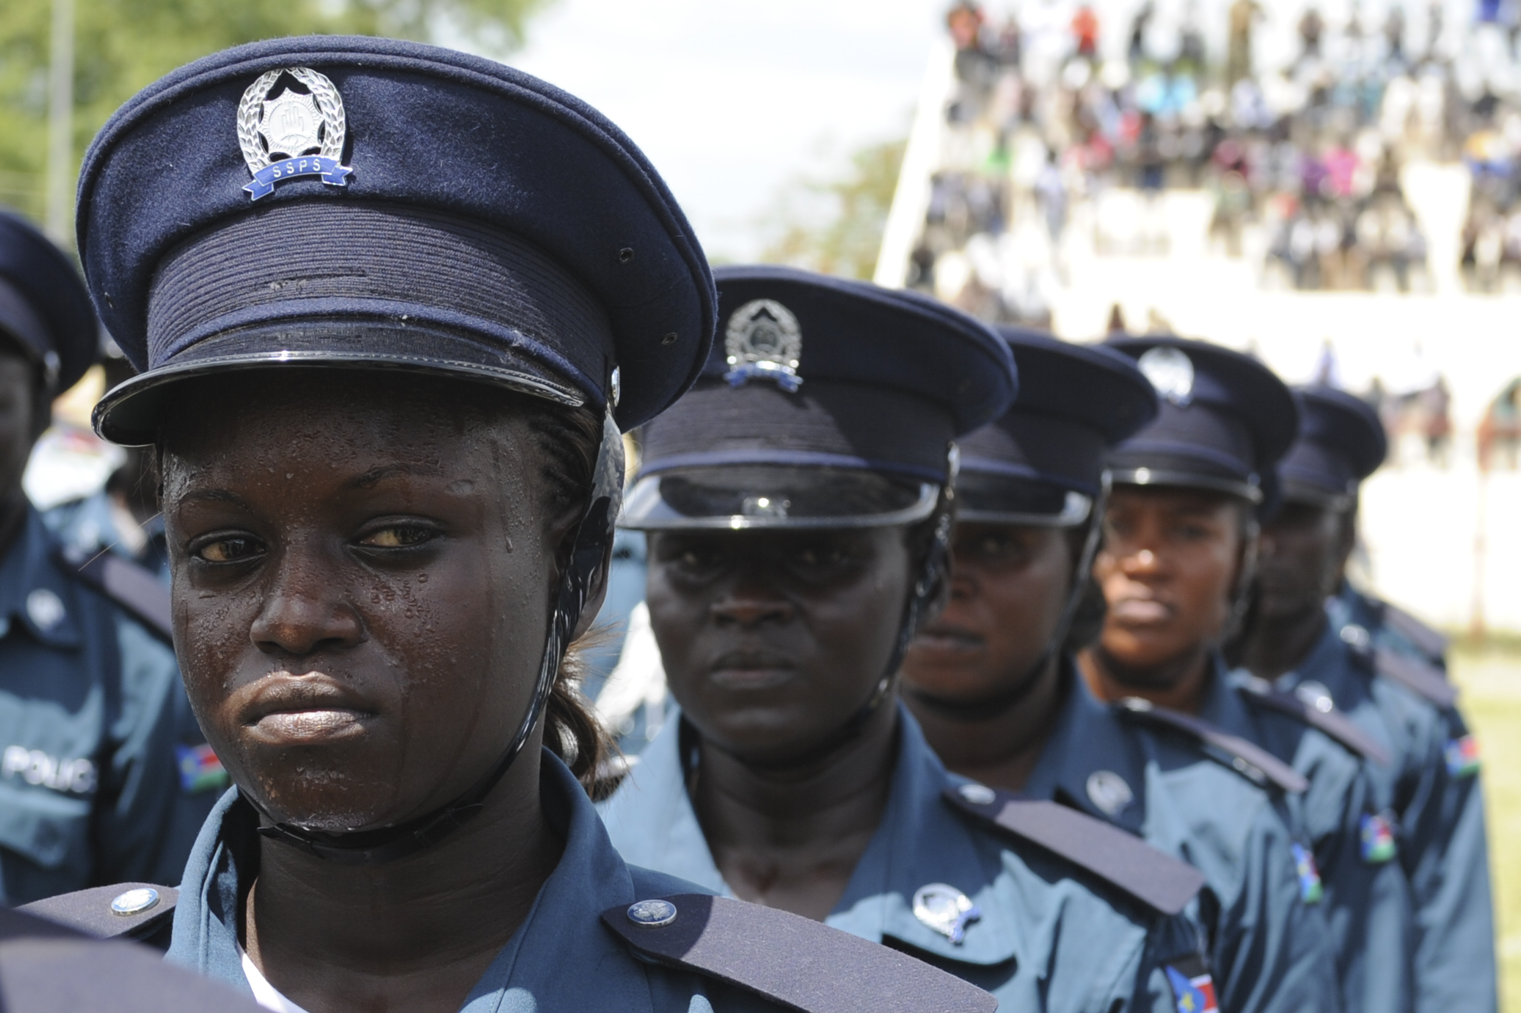
Photo: UN Photo/Isaac Billy
The overall evaluation plan for the Regional Programme Document for Africa (RPD) 2014-2017 which will be implemented through five regional project documents is attached to this project document under Annex 1.

In accordance with the programming policies and procedures outlined in the UNDP User Guide, the project will be monitored through the following:
Within the Project Cycle:
- On a quarterly basis, a quality assessment by both the RSC Project Management Team (PMT) shall record progress towards the completion of key results, based on quality criteria and methods
- UNDP shall activate and regularly update a Risk, Issue and Monitoring logs (annex 1) to facilitate tracking and resolution of potential problems or requests for change.
- A project lessons-learned log shall be activated and regularly updated by the Project Management Team to ensure on-going learning and adaptation within the project cycle, and to facilitate the preparation of the Lessons-learned Report at the end of the project.
Monitoring and Evaluation Schedule Plan shall be developed by the PMT at the inception phase to facilitate proper, timely and effective monitoring of key milestones. This will seek to track and capture key management and implementation outcomes and changes
Within the annual cycle
- Quarterly Project Report (QPR): The PMT will prepare quarterly project reports. As a minimum requirement, the quarterly project report shall consist of the UNDP Atlas standard format and will provide a summary of results achieved against pre-defined annual targets at the output level. Quarterly reports will be submitted on the 15th of the preceding month.
- Annual Review Report. The PMT will prepare one integrated annual progress report. As a minimum requirement, the Annual Review Report shall consist of the UNDP standard format for the QPR covering the whole year with updated information for each element of the QPR as well as a summary of results achieved against pre-defined annual targets at the output level.
- Annual Project Review. Based on the above report, an Annual Project Review shall be conducted during the fourth quarter of the year or soon after, to assess the performance of the project and appraise the Annual Work Plan (AWP) for the following year. In the last year of the project life, this review will be a final assessment. This review will be driven by the Regional Project Advisory Board. It shall focus on the extent to which progress is being made towards outputs, and that these remain aligned to the project outcome. The Annual Report shall be completed and submitted to the RAPB UNDP by the end of the 1st month of the following year.
- Completion of Project: The regional project will be subject to a final evaluation. The evaluation will seek to assess the delivery of results and achievements based on objectives and outcomes.
- Final Project Report: The PMT shall submit the final regional project report within 3 months after the completion or termination of the activities, including a list of non-expendable equipment purchased and all relevant audited or certified financial statements and records related to such activities, as appropriate, pursuant to its Financial Regulations and Rules.
- Audits: This project shall be subject to annual audits in terms of the UNDP rules and regulations.
The project will use various monitoring tools to assess progress against stated outputs and key deliverables. These include meetings, internal quarterly progress reports prepared by the Regional Project Manager. The Project Manager shall also prepare annual reports and a final report. Reports shall be shared with all stakeholders. A mid-term evaluation will be conducted by an independent expert .The evaluation report will be discussed by the Regional Advisory Board who on the basis of evaluation results will make adjustments to the project implementation, if necessary. Upon completion of the project an independent evaluator will assess the overall achievements of the project. This will include the assessment of effectiveness and efficiency of the design and implementation of the project, management arrangements, activities and achievements against stated objectives and impact of the project on the AUC, the RECs and identified countries
Quality Management for Project Activity Results
Replicate the table for each activity result of the AWP to provide information on monitoring actions based on quality criteria. To be completed during the process “Defining a Project” if the information is available. This table shall be further refined during the process “Initiating a Project”.

OUTPUT 1:
Activity Result 1  (Atlas Activity ID) | Short title to be used for Atlas Activity ID |  | Start Date:  End Date:
Purpose | What is the purpose of the activity?
Description | Planned actions to produce the activity result.
Quality Criteria  How/with what indicators the quality of the activity result will be measured? |  | Quality Method  Means of verification. What method will be used to determine if quality criteria has been met? | Date of Assessment  When will the assessment of quality be performed?

Legal Context
Consistent with the Article III of the Standard Basic Assistance Agreement (SBAA), the responsibility for the safety and security of the Implementing Partner and its personnel and property, and of UNDP’s property in the Implementing Partner’s custody, rests with the Implementing Partner. To this end, the Implementing Partner shall:
- Put in place an appropriate security plan and maintain the security plan, taking into account the security situation in the country where the project is being carried;
- Assume all risks and liabilities related to the implementing partner’s security, and the full implementation of the security plan.
UNDP reserves the right to verify whether such a plan is in place, and to suggest modifications to the plan when necessary. Failure to maintain and implement an appropriate security plan as required hereunder shall be deemed a breach of the Implementing Partner’s obligations under this Project Document.
The Implementing Partner agrees to undertake all reasonable efforts to ensure that none of the UNDP funds received pursuant to the Project Document are used to provide support to individuals or entities associated with terrorism and that the recipients of any amounts provided by UNDP hereunder do not appear on the list maintained by the Security Council Committee established pursuant to resolution 1267 (1999). The list can be accessed via http://www.un.org/sc/committees/1267/aq_sanctions_list.shtml. This provision must be included in all sub-contracts or sub-agreements entered into under/further to this Project Document

ANNEXES:
Annex 1: Evaluation Plan for the RBA Regional Programme 2014-2017
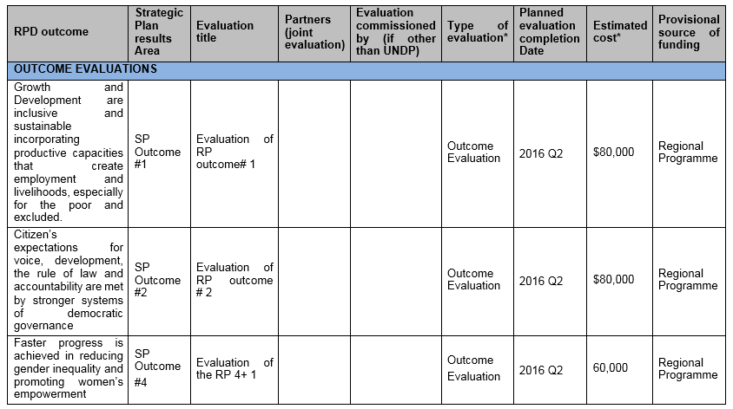

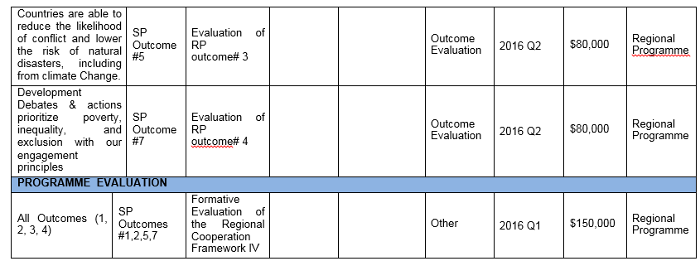

Assumptions:
- The Evaluation of Regional Programme by IEO will be completed by Q3/Q4 of 2016 in time to feed into the design of the next RP
- Outcome evaluations of all four Regional Programme Outcomes are planned to feed into this independent evaluation.
- Formative evaluations of the Regional Programme will cover all five Regional Projects and will provide timely information to the managers if the Regional Programme and the constituent projects were conceptualized correctly (will notable modifications be needed for the design to work), capacities are in place, if all projects have synergies and work towards outcomes as intended, and if the programme is likely to deliver results in a timely manner, etc.
- * These are estimated costs. A better estimate of each evaluation will be derived from the cost of such evaluations during the previous cycle – to be provided by the Regional programme management in Addis.

Annex 2: UNDP Lessons Learnt from RPD 2008-2013

Summary of Recommendations from RPD 2008-2013:
- Addressing capacity constraints within UNDP and responsible partners in order to correct programme design and implementation delays
- Better coordination with other regional partners to ensure sustainability for results and support to regional bodies
- Need for long-term strategy for engagement with AUC and RECs including developing sub-regional strategies
- Emphasizing regional public goods and cross-border challenges and continue to leverage UNDP country presence
- Greater attention to the mainstreaming of gender
- Focus on fewer and more strategic programme outcomes
- Documenting good practices
- Better management of the development of knowledge products to ensure impact and visibility on UNDP thought leadership
- Better coherence and coordination of the components of the regional programme

UNDP/RBA Responses to Recommendations:
- Extensive consultative process with partners in the design of the regional projects including with RPD Advisory Board, AUC/RECs/NEPAD/APRM/CSOs
- Preparation of a long term strategy for engagement with AUC and RECs is underway
- Additional outcome to RPD 2014-2017 to address mainstreaming of gender across the projects
- RPD Support project was developed to support robust monitoring and evaluation systems
- Detailed Business Process and Accountability Framework was developed and endorsed by the RBA Director. The Business process minimizes silos and ensures coherence through joint planning, knowledge management systems and mission planning among others things
- More stringent internal review and consultations within UNDP including Exo, BPPS/DIG and CO’s.

Annex 3: Regional Programme Risk Mitigation

RISK |  | MANAGEMENT RESPONSE
Conceptual framework and theory of change may be overtaken by emerging issues in rapidly changing development environment in Africa |  | - The regional programme has a robust evaluation plan and monitoring framework to ensure that the programme/projects remain relevant.  - The regional Programme has developed a contingency plan to respond the emerging issues that need a regional response by UNDP.
 | UNDP investments and support to regional bodies and frameworks are translated into national development plans |  | - UNDP utilize its national presence to domesticate key regional frameworks into national development plans.  - Encourage partners in the other sectors to ensure domestication of regional frameworks.
 | Lack of adequate resources will present a challenge in achieving the results of the regional programme and component project. |  | - UNDP is currently developing a regional programme resource strategy to ensure additional resource are secured for the programme  - A sustained and visible communication strategy will be developed for the regional programme in order to attract further partnerships and resource for the RP.
Conceptual framework and theory of change may be overtaken by emerging issues in rapidly changing development environment in Africa |  | - The regional programme has a robust evaluation plan and monitoring framework to ensure that the programme/projects remain relevant.  - The regional Programme has developed a contingency plan to respond the emerging issues that need a regional response by UNDP.
UNDP investments and support to regional bodies and frameworks are translated into national development plans |  | - UNDP utilize its national presence to domesticate key regional frameworks into national development plans.  - Encourage partners in the other sectors to ensure domestication of regional frameworks.
Lack of adequate resources will present a challenge in achieving the results of the regional programme and component project. |  | - UNDP is currently developing a regional programme resource strategy to ensure additional resource are secured for the programme  - A sustained and visible communication strategy will be developed for the regional programme in order to attract further partnerships and resource for the RP.

Africa Economic Outlook 2014
Africa’s Pulse 2014
Oxfam "Africa's Missing Billions, 2008
World Economic Forum (2013) The Global Gender Gap Report 2013
Africa MDG Report 2014 (AUC/AfDB/UNDP/UNECA, 2014)
Africa MDG Report 2014
This is reflected in several regional protocols, charters, agendas and declarations, principally: Agenda 2063, the shared values agenda, the common position on the post-2015 development agenda, and the OAU 50th anniversary declaration.
General Assembly Resolution 67/266

